### An Introduction to Machine Learning

26 June 2021

*(Understand the basic concepts in Machine Learning )*

#### **Let's Start...!!**

Machine learning is a subfield of Artificial Intelligence (AI) and its approach is completely different from usual traditional way of computer programming. In general, computers are performing based on an explicitly given programs or instructions, wherein ML, computers are learning by themselves. In ML, computers are getting trained by the input data set, and becoming able to take decisions, similar to how people are taking decisions from their experiences. From past experiences and understandings, people will tackle the situations accordingly. To achieve this, we need to train the computers with lots of data through different ML algorithms.

In this post, let's have a look on the following concepts.

* Types of Machine Learning

1. Supervised Learning

2. Unsupervised Learning

3. Reinforcement Learning

* Final Notes

#### **Types of ML Algorithm**

Based on the Learning approach, Machine Learning algorithms can be categorised and following are the prominent three of them.

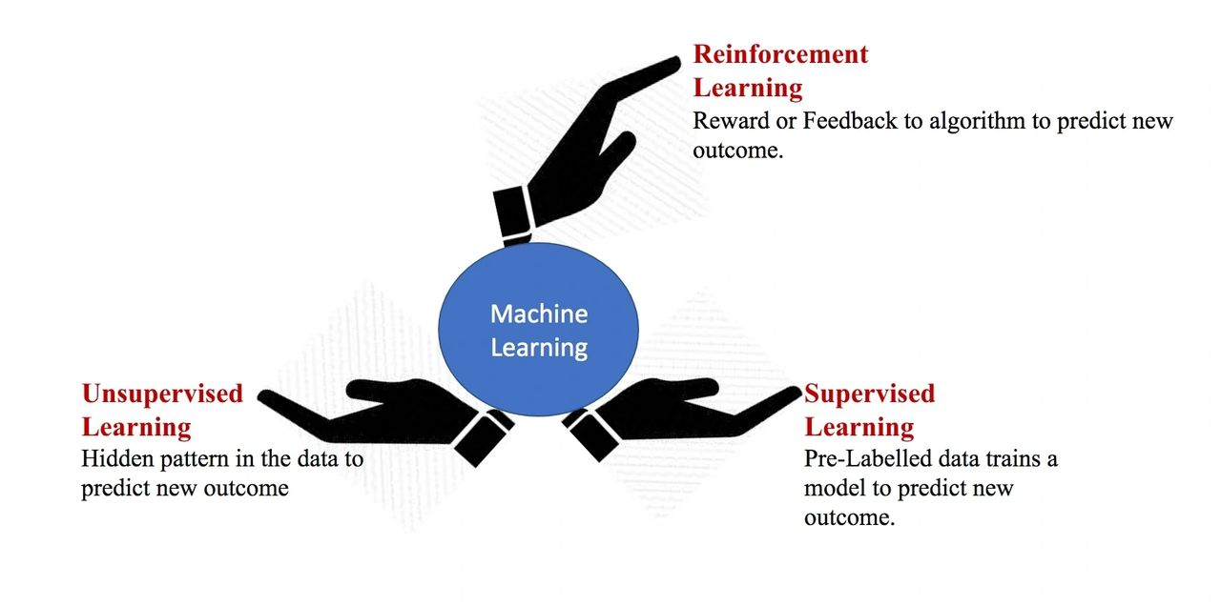

Listed below are the popular algorithms across each category mentioned above.

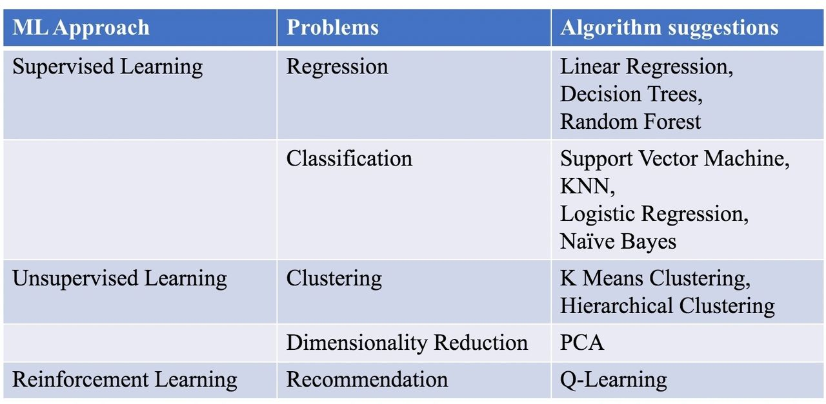

#### **Supervised Learning**

Supervised Learning is one of the Machine Learning algorithms, used to solve Prediction (Regression) and Classification problems. The Training data will contain a target or dependent variable and predictors or independent variable. In other words, supervised learning algorithms are trained with labelled data. Using this Training data set, algorithm will build a model which can be used for predictions on a new data set. This training and testing procedure will continue based on different algorithms until getting a model with a good accuracy score.

Let’s discuss and understand the above facts through one sample Regression problem.

***Problem:*** *Fruits Label Prediction*

***Data set:***

*Target variable: Fruit label*

*Feature variable: Fruits(Apple & Orange) features such as colour, size etc.*

***Expected Output:*** *Label: Apple & Orange*

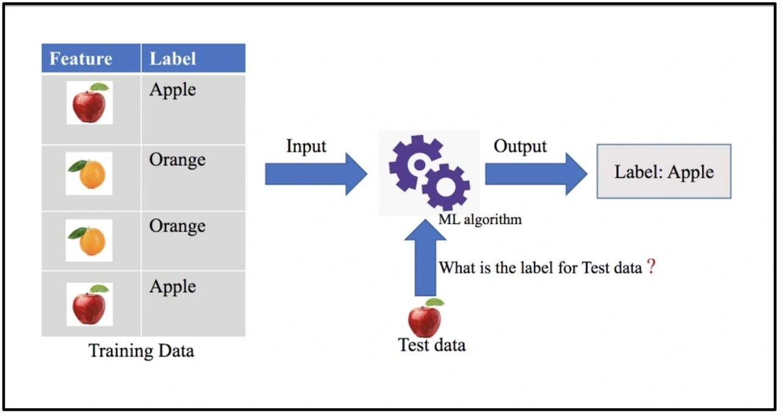[Fig: Solution Pipeline](https://img1.wsimg.com/isteam/ip/74148d29-90e5-49b3-b441-126a942e0518/Screen%20Shot%202021-06-26%20at%2011.35.23%20PM.png/:/rs=w:1280)

#### **Unsupervised Learning**

It is the next type of Machine Learning algorithm mainly used to solve Classification and Clustering problems. In this approach, training data set will not contain any labelled data, it consists features variables only. So, model needs to discover the hidden pattern in the training data and needs to learn on their own.

Unsupervised algorithms can build a model based on the identified pattern, which can be used for the classification of a new data set.

As we discussed in Supervised Learning, let’s consider these facts in a problem solving approach.

***Problem:*** *Fruits Label Classification*

***Data set:***

*Feature variable: Fruits(Apple & Orange) features such as colour, size etc.*

***Expected Output:*** *Classes: Apple & Orange*

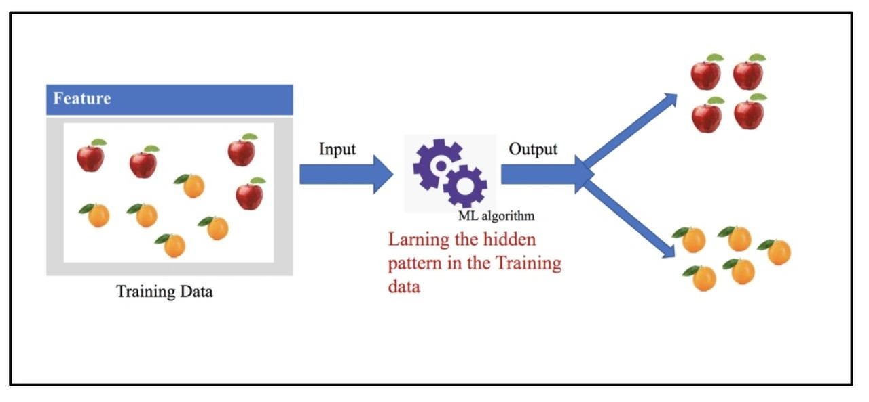Fig: Solution Pipeline

#### **Reinforcement Learning**

Reinforcement learning is a type of machine learning algorithm which forms a strategy from the past actions. Reinforcement Learning approach designed on the basis of a reward – punishment system. For each step, the model is getting rewards for correct moves and if it is a wrong one, it will be a punishment. In doing so iteratively, the model will be efficient in making decisions.

***Problem:*** *Fruits Label Recommendation*

***Data set:***

*Feature variable: Fruits(Apple & Orange) features such as colour, size etc.*

***Expected Output:*** *Label: Apple & Orange*

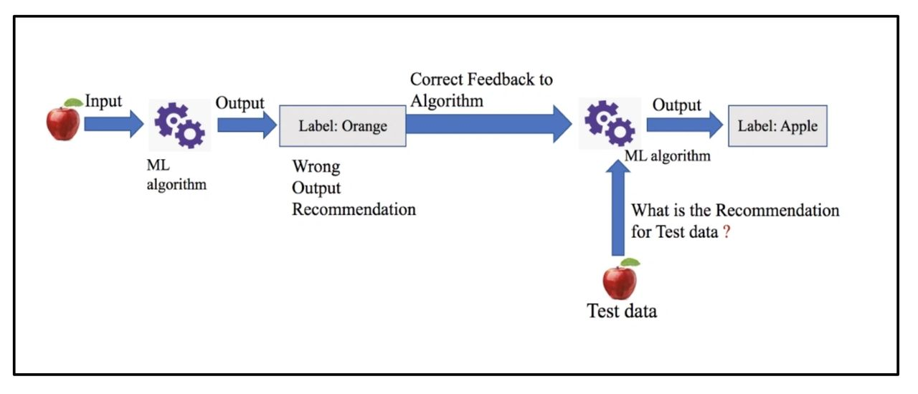Fig: Solution Pipeline

#### **Final Notes**

Machine Learning has immense role in many fields such as Banking, Insurance, Education etc and it is growing in exponential rate in this drastically changing world. Even though we are focusing only at Three major types of Machine Learning, there are different aspect to look at Machine learning world. But Supervised, Unsupervised and Reinforcement Learning are the prominent ones.

It is bit tricky to choose the right machine learning algorithm for the problems in hand. However, there are efficient ML tools are available which can build a model with good accuracy measure for a given problem. And it is possible to improve the models over time by training the models.